# CSS3 Animations

*The CSS3 animations feature allows you to create keyframe animations.*

CSS3 animations allows animation of most HTML elements without using JavaScript or Flash!

# What are CSS3 Animations?

An animation lets an element gradually change from one style to another.

You can change as many CSS properties you want, as many times you want.

To use CSS3 animation, you must first specify some keyframes for the animation.

Keyframes hold what styles the element will have at certain times.

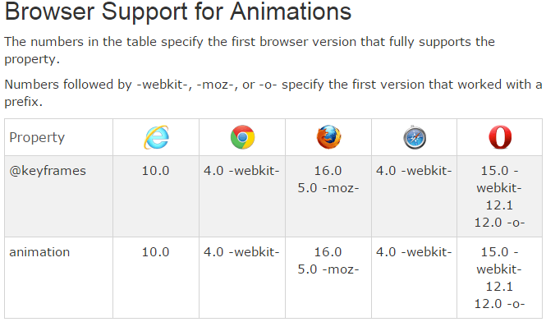

# The @keyframes Rule

When you specify CSS styles inside the @keyframes rule, the animation will gradually change from the current style to the new style at certain times.

To get an animation to work, you must bind the animation to an element.

The following example binds the "example" animation to the <div> element. The animation will lasts for 4 seconds, and it will gradually change the background-color of the <div> element from "red" to "yellow":

/* The animation code */  
@keyframes example {  
    from {background-color: red;}  
    to {background-color: yellow;}  
}  
  
/* The element to apply the animation to */  
div {  
    width: 100px;  
    height: 100px;  
    background-color: red;  
    animation-name: example;  
    animation-duration: 4s;  
}

# Defining Keyframes

Keyframes are used to specify the values for the animating properties at various stages of the animation. Keyframes are specified using a specialized [CSS at-rule](http://www.tutorialrepublic.com/css-reference/css-at-rules.php) — @keyframes. The keyframe selector for a keyframe style rule starts with a percentage (%) or the keywordsfrom (same as 0%) or to (same as 100%). The selector is used to specify where a keyframe is constructed along the duration of the animation.

* The animation code */  
@keyframes example {  
    0%   {background-color: red; left:0px; top:0px;}  
    25%  {background-color: yellow; left:200px; top:0px;}  
    50%  {background-color: blue; left:200px; top:200px;}  
    75%  {background-color: green; left:0px; top:200px;}  
    100% {background-color: red; left:0px; top:0px;}  
}  
  
/* The element to apply the animation to */  
div {  
    width: 100px;  
    height: 100px;  
    position: relative;  
    background-color: red;  
    animation-name: example;  
    animation-duration: 4s;  
}

# Delay an Animation

The animation-delay property specifies a delay for the start of an animation.

The following example has a 2 seconds delay before starting the animation:

div {  
    width: 100px;  
    height: 100px;  
    position: relative;  
    background-color: red;  
    animation-name: example;  
    animation-duration: 4s;  
    animation-delay: 2s;  
}

# Set How Many Times an Animation Should Run

The animation-iteration-count property specifies the number of times an animation should run.

The following example will run the animation 3 times before it stops:

div {  
    width: 100px;  
    height: 100px;  
    position: relative;  
    background-color: red;  
    animation-name: example;  
    animation-duration: 4s;  
    animation-iteration-count: 3;  
}